Child Care and Learning Center
Parent Handbook
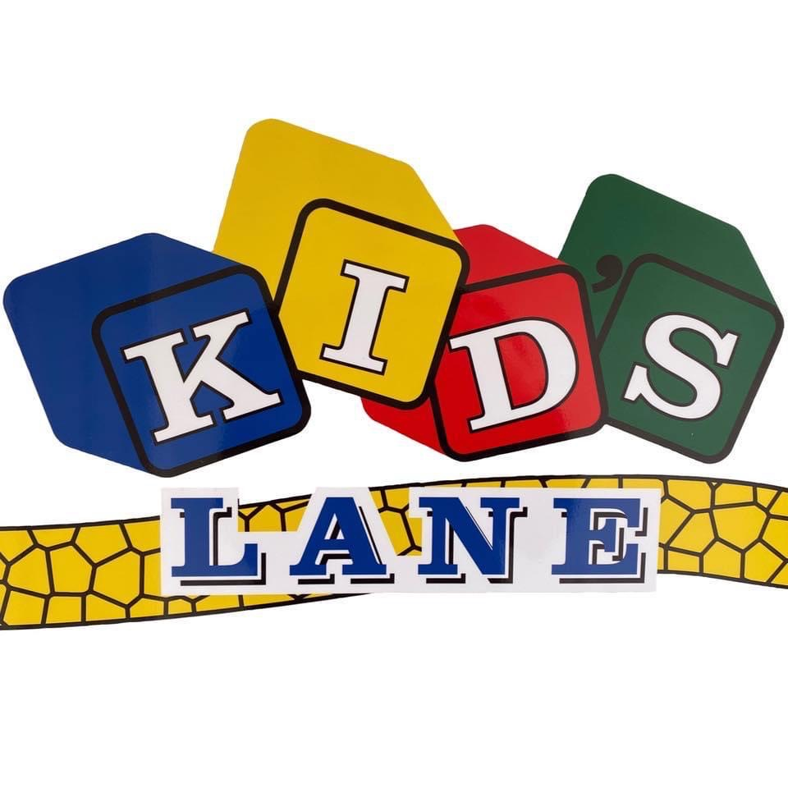
2022-2023

Office: 860-563-6205
kidslanect@gmail.com
kidslanect.com
38 New Britain Drive
Rocky Hill, CT

Hours:
Monday-Friday: 6:30 AM – 6:00 PM
Dear Parent,

Welcome to Kid’s Lane Daycare. Our staff is committed to ensuring your child is taken care of in the most effective and safe environment. While at Kid’s Lane, our staff will make sure the individual developmental needs of your child are always met.
This handbook has been prepared specifically for you, the parent / guardian. We have shared our philosophy, our program guidelines, and our policies. It is a very important tool to reference while enrolled with us.
We encourage you to read through this handbook and use it as a reference for any questions or concerns you may have. Feel free to discuss any of these topics with me at any time.
Kid’s Lane is passionate about working as a team in your child’s growth and development. You are always welcome here and we encourage you to share ideas, concerns, or offer suggestions. Thank you for choosing Kid’s Lane!
Sincerely,

Paul Baronich
Director

Contents
4 Our Mission
4 Enrollment Schedule
4 Tuition
5 Withdrawal Policy
5 Learning Centers
5 Rest Time & Toys
5 Proper Dress
6 Lunches & Snacks
6 Hi Mama
6 Medication
7 Health & Safety Files
7 Hours of Operation
7 Arrival and Departure
8 Transportation
8 Ratios
9 Teachers
9 Guidance & Discipline
10 Grievance Procedure
10 Conditions That Require Temporary Exclusion
11 Illness
12 Safe Sleep
12 Emergency Response Plans
14 Parent Handbook Agreement Form
15 Child Enrollment Information Forms
19 Emergency Medical Form
20 Receipt of Discipline Policy
21 Permission to Photograph
Our Mission
Kid’s lane is an independent learning center dedicated to providing the most nurturing care of your child. Since 1997, our mission has and will always be to partner in the growth and development of your child and ensuring their individual needs are always met. Our staff strives to build better futures for young children and provide quality early childhood education and services for families, early childcare professionals, and the community.
Kid’s Lane believes that in order to achieve our mission, we need to work as a team. Our vision for this center is always growing and evolving and we want to ensure it is the best it can be for you and your child. We value each of you and consider you all a part of our family.
Enrollment Schedule
When you enroll your child, you will be asked to complete an “Enrollment Schedule Sheet”. The information given is used to schedule staff and develop an “Enrollment Chart” to ensure our enrollment limit is never exceeded (both of which are State mandated). It is very important that the schedule you submit be adhered to. No deviations from the “Enrollment Schedule Sheet” are permitted unless our Director has given prior approval and the deviation requested does not compromise the conditions of our license. If approval is given, a fee may be incurred to cover staff adjustments etc.
Tuition
Payment is due at the beginning of each week. Because expenses continue regardless of attendance, we cannot offer a reduction in fees regardless of school closings or absences of any kind. If payment is not received, a $25.00 (per week) late fee will be applied, and your child’s space is no longer secure. If payment is not brought current within two weeks (including late fees) your child will be removed from enrollment. If you have any trouble meeting your payment obligation, please talk to the Director immediately. A $37.00 charge will be added for a returned check. Quoted weekly charges are based on 9 hours per day enrolled. Any time after the 9th hour per day will be charged an additional $10.00 per hour. Enrollment fees can change at any time with a 30-day notice.

Withdrawal Policy
A two-week notice (or payment of fees that would cover this period) must be given if a child is removed from Kid’s Lane for any reason initiated by their parent(s)/guardian(s). Kid’s Lane reserves the right to terminate a child’s space if terms of this document have not been met, a child’s actions or behavior could be deemed harmful or continually disruptive to the staff or children or any other reason deemed unacceptable.
Learning Centers
At Kid’s Lane, our staff assists families in providing their children with the foundations for success in school and life. At this center the children are provided with a high-quality, comprehensive early childhood education program in a safe and caring environment. As we gradually grow and expand, we make sure our future needs for the center and the children will always be met. Throughout the day, children participate in a variety of activities individually and as a group. Our comprehensive curriculum ensures the children will reach their full potential and reflects the family values, beliefs, experiences and cultures of all enrolled children. Based on principles of child development, our program fosters in children an understanding of self, others, and community.
Rest Time & Toys
All children are given a period to rest during the afternoon after lunch. Please Note: We do not require any children to sleep; we can only encourage each child to rest during this period. A small stuffed animal and/or favorite blanket from home are also welcome. Your child may bring a stuffed animal, blanket, doll, etc. to assist in adjusting to their new surroundings; for rest time we request no other toys to be brought in. Every Thursday is Show & Tell and your child is welcome to bring in a toy for them to share with the class during this time only. Violent toys i.e., toy guns and knives are not appropriate and are prohibited from being brought into the Center. We also request that candy or gum not be brought in; thank you in advance for adhering to this request.
Proper Dress
Water activities, sand play and occasional bathroom accidents necessitate that extra set(s) of clothes be kept at the school. All extra clothing should be marked with your child’s name. If clothing is sent home, please return a clean set the next morning. In case of emergency, we have some extra clothes in the Center. If your child is sent home in clothes belonging to Kid’s Lane, we ask that you wash them and return them the next day. Please remember that your child plays outside daily (weather permitting) and should be dressed accordingly.
Lunches & Snacks
Kid’s Lane does not provide meals throughout the day. Parents/guardians of children under 2 are required to bring in lunches and snacks daily. Parents/guardians of children 2 and over are required to bring their child breakfast is necessary and lunch daily. The center provides morning and afternoon snacks that follow the USDA government child nutrition guidelines.
Hi Mama
Our staff use an app each day called Hi Mama. When you first enroll your child, you will be asked for your email so we can add you to the app. This app is downloadable on your phone or tablet and is a great way to know what your child is doing throughout the day. The staff will be able to write down everything that happens throughout such as diaper changes, how much they ate during lunch and snack, napping, the activities they did, behaviors, etc. We will be able to notify you about any supplies you may need to bring in. The teachers also upload pictures of your child throughout the day, so you know they are doing well! If you have any concerns or requests, you can message your child’s teacher directly through the app and they will respond in a timely matter. The Hi Mama app is a great way to stay engaged in your child’s day and makes it easier for our staff to stay connected with you and your child!
Medication
If your child is on medication, you must complete an Authorized Medication form. Medications must be prescribed by a physician and be brought to the Center in pharmacy-labeled containers. Non-prescription medications can be given provided a parent/guardian submits a written order from the physician. Any non-prescription diaper creams, medicated powders and ointments require only a note from the parent/guardian. Sunscreen has its own form that needs to be completed when brought into the center. Our staff has completed trainings on giving medications to your children. This ensures that someone trained in the procedure will always be on-site to distribute the medications to your child.

Health & Safety Files
Upon enrollment, Kid’s Lane requires various health and safety paperwork i.e., physical forms and immunizations. All your child’s paperwork will be put into a folder and securely placed in the office. These files are not to be shared or looked at but are immediately available upon request to administrators and teaching staff who have consent from a parent of legal guardian to access records, the child’s parents or legal guardians or regulatory authorities.
Hours of Operation
Kid’s Lane Daycare Center is open 6:30 AM to 6:00 PM, Monday-Friday, except on holidays when the center will be closed. These days include:
- Good Friday
- Memorial Day
- Independence Day
- Labor Day
- Thanksgiving
- Christmas
- New Years
Arrival and Departure
To ensure your child(ren) get the most out of their time at Kid’s Lane, we encourage they arrive to the center by 9:30 AM. This consistency provides children with the benefit of our educational curriculum. Each day your child’s teacher will record their attendance on the Hi Mama app to keep an accurate record of hours in the center. However, we require you to walk your child to and from their classroom upon arrival and departure. This allows staff to have daily contact with you and ensures that your child is carefully supervised.
When dropping off your child at the center, please do not keep your car running in the parking lot. Cars are not allowed to be left idling during arrival or departure unless it is to maintain temperature for extreme heat or cold.
When you first enroll your child, you will be given a key fob and the option to choose a personal code to get in the building. These fobs and codes are not to be shared; they are for each individual parent/guardian. The key fob and code is the only way an authorized adult can enter the building, ensuring the safety of your child and our staff. If you lose your fob, please let the director know immediately so we can replace it.
Children cannot be dropped off and allowed to enter the Learning Center alone. We will also not release a child to anyone whom the parent/guardian has not given written permission for us to do so. Any guardian listed on your child’s enrollment paperwork will be granted permission to pick up your child, unless you have given legal documentation to the Center Director stating otherwise. Any authorized person picking up a child is required to have a photo ID.
If the adult authorized to pick up a child seems disoriented or displays impaired judgement, our staff have the right to call an emergency contact to pick up the child for their safety. If attempts to keep the child safe from the disoriented authorized adult are unsuccessful, the police will be contacted.
If an authorized individual is late to pick up, the child will stay in the center under the supervision of the director or a caretaker. If an authorized individual does not show up, an emergency contact will be notified to pick up the child. If no one responds or arrives within 30 minutes the authorities will be contacted in an attempt to locate a responsible party.
Verbal and physical abuse toward other adults or children are not tolerated on Kid’s Lane premises. This includes profanity and derogatory remarks. Video surveillance systems are used throughout the Kid’s Lane Learning Center for the safety and security of children, staff and families. The Director has access to view the recordings at any time. Kid’s Lane staff will contact the police when necessary.
Transportation
Kid’s Lane Daycare does not offer our own transportation services. However, if the parent or guardian has set up a mode of transportation for their child for before and after school or any programs throughout the day, we are more than happy to accommodate for you. When the child departs from the center, they will be checked out via the Hi Mama app and checked back in when they arrive back at the center. This ensures all the children are accounted for and the center stays in ratio.
Ratios
As a licensed program, our ratios always meet the state requirements. Child/staff ratios vary with each classroom as attendance shifts.
Age Category Ratio | Teacher to Child | Maximum Class Size
Infant | 1:4 | 8
Toddler | 1:4 | 8
Preschool | 1:10 | 20
School Age | 1:10 | 20

Teachers
All children enrolled in the Center will be assigned to a classroom and teacher who is primarily responsible for their daily care. Each classroom is assigned the same teacher daily, ensuring your child spends most of their day with the same caretaker. Your child will stay with this teacher until their age and stage of development indicates that it is appropriate for a move to a new classroom. Infants and toddlers will stay with the same teachers for nine months or longer to ensure they’re educational development is consistent, and they get a sense of routine and safety to carry through for the length of their full enrollment. As attendance shifts throughout the day, teachers and children may move to different classes in order to keep ratio, however our staff is dedicated to working as a team and stays relatively consistent each day.
Guidance and Discipline
Discipline means learning. It does not mean punishment, tears, or humiliation. It means a chance to learn how to live in a social world. Discipline is not something adults do to their children; it is something they do with their children.
The goals of discipline are self-control and responsibility. Teachers and parents are most likely to achieve these goals when they respond to the causes of behavior, as well as to the behaviors themselves. The use of physical punishment and threats of any kind are prohibited for teachers, staff and parents on Kid’s Lane premises. Research shows that physical or emotional punishment demeans the child and does not support positive changes in the child’s behavior over the long term.
Teachers may use a variety of discipline techniques to meet the needs of different situations:
- Let children make their own decisions and choices. One good way to teach responsibility is to give the child the opportunity to make choices.
- Allow children to attempt to resolve the issue before the teacher gets involved. If the issue continues or escalates the teacher will immediately get involved.
- Give reasons for rules. Understanding the reasons for rules makes it easier to remember and follow them
- Recognize and encourage positive behavior
- Redirect the child’s behavior. Often there is a way to let children do something in a better place or a safe way.
- Be consistent in language and behavioral response to children. Adults’ consistent behavior helps the development of inner control through modeling.
When a challenging behavior is ongoing or potentially dangerous to the staff, the other children or the child themselves and the techniques described above have all been exhausted, Kid’s Lane will take the following steps to avoid exclusionary measures.
- Parents are informed of problem behavior, including incident reports posted on the Hi Mama app.
- Parents and staff work together to develop a behavioral plan
- Parents will be contacted to pick up their child if their challenging behavior continues or becomes dangerous.
- If all intervention measures have been exhausted resulting in no positive changes, Kid’s Lane may request that a child be removed from the program.
The goal of Kid’s Lane Learning Center is to provide a positive environment in which children can succeed. Parents and all components within our program have a role in making this goal a reality. Every step should be taken to support the success of both the children and the families that make up this program. The parents/guardians must be involved in attempts to address concerns with their child. Without parental cooperation, there is very little we can do to help the child reach their full potential.
Grievance Procedures
Any parent/guardian who believes that they have a justifiable request or complaint should discuss the concerns with the teacher caring for their child. If the issue is not resolved, it should be discussed with the Center Director. Every effort will be made to reach a mutually satisfactory solution of the matter.

Conditions That Require Temporary Exclusion
It is impossible to keep a child who has a cold at home every time. However, a child who is running a fever of 100 axillary (under the arm) or higher, has diarrhea, has vomited or shows signs of an infection should not be sent to school. If these symptoms occur once your child is at Kid’s Lane, we will notify you to pick up your child. When waiting for your arrival, we will keep your child comfortable and isolated from other children.
You must let us know immediately if your child has a contagious disease, (such as COVID, chicken pox, strep throat, hand-foot and mouth, pink eye, ringworm, head lice, etc.). If your child is on prescribed antibiotic, they must receive the medication for at least 24 hours and be fever free (below 100 degrees) before returning to the Center. In circumstances where a communicable disease has been identified in a classroom, Kid’s Lane will notify parents by email, the Hi Mama app or in person that your child may have been exposed and will provide information on what symptoms to look for.
Vomiting is not usually a normal response of healthy children. Occurrences at the center could result in exclusion.
Diarrhea in infants and toddlers in excess of two liquid stools in an 8-hour period, or an increased number of stools compared to the child’s normal pattern may be a symptom. Diarrhea in preschool children that is not contained in the toilet and/or in excess of two liquid stools in an 8-hour period is also not a normal response in healthy children. Children need to be excluded until diarrhea is gone for 24 hours.
All medication is stored under lock and key in the office. Only staff trained by a CT State Authorized Agency for the administration of medication can administer medicine. We will NOT give your child Tylenol or other fever reducing drugs to lower your child’s temperature. If your child has a temperature over 100 axillaries (under the arm), they are considered contagious and will be sent home to your care. Keep your emergency contacts up to date to make sure this is an easier process for your sick child, your family, and staff involved.
Illness
Children who are not feeling well cannot fully participate in the activities planned at the Learning Center. For your child’s well-being and the protection of other children, please keep your child at home when they have any of the following symptoms.

- Vomiting
- Diarrhea
- Sever cold with cough
- Axillary (underarm) temperature of 100 degrees
- Child does not feel well enough to participate in the normal
- Undiagnosed rash
- Earache
- Sore throat or difficulty swallowing
- Runny nose not due to a diagnosed condition

Safe Sleep
Providing your infant with a safe environment in which to grow and learn is extremely important to us. To that end, our childcare facilities have implemented policies and procedures to create a safe sleep environment for your infant. We follow the recommendations of the American Academy of Pediatrics (AAP) and the Consumer Safety Commission for safe sleep environments to reduce the risk of sudden infant death syndrome (SIDS). SIDS is “the sudden death of an infant under 1 year of age, which remains unexplained after a thorough case investigation, including performance of a complete autopsy, examination of the death scene, and review of the clinical history.” Our written policy is as follows:
• All infants will be placed on their backs in a safety-approved crib unless an alternate sleep position is needed for a medical reason documented by a written note from the infant’s health professional. This note needs to include the medical reason and to what degree the mattress needs to be inclined in centimeters/inches.
• Infants will not sleep on water beds, sofas, soft mattresses or other soft surfaces.
• Soft materials, such as pillows, blankets, quilts, comforters, sheepskins, stuffed toys and loose bedding, will not be placed in infants’ sleep environments.
• Infants will not share a safety-approved crib with other children.
• Supervised “tummy time” will be observed while the infant is awake.
Since the start of the 1994 national campaign that provided guidelines for parents, health professionals and other caregivers to place infants on their backs to sleep, the number of infants dying of SIDS has decreased significantly.
Emergency Response Plans
Emergency Evacuation Plan
In the event Kid’s Lane Daycare and Learning Center must be evacuated, we will relocate to the Fire House located next door. Staff have been given the signs and signals of a variety of emergencies (E.g., tornado, hurricane, flood) and what action to take in these situations. Quarterly drills, including instruction on relocation and evacuation have been put into place. Staff and children have been informed during drills where they must go in case of evacuation. All parents are notified of our plans and procedures upon enrollment.
Infants will need assistance when relocating. Each infant room teacher will place up to 4 infants into a crib in order to wheel them out. If the center is forced to evacuate, all parents will be notified using the contact information located in the evacuation notebook (once all children are safely relocated). An emergency kit is maintained in the back room and should be taken along in case of evacuation.
We have an emergency kit for evacuation or shelter in place. In our emergency kit there is a diagram of the facility, a checklist of what needs to be brought along and an emergency attendance list used specifically for an emergency.
If children need to be transported further than the Fire House, parents have been asked to provide transportation for their child.
Emergency Weather Plan
In the event of a severe weather warning, parents/guardians will be contacted to pick up their child. In the event of severe weather that is not forewarned, not to be limited to tornadoes or hurricanes, the staff is to remain calm and move children to the center of the building, away from windows and objects that may pose a hazard and protect and comfort them until the severe weather passes.
Emergency Fire Plan
In the event of a fire, children shall be escorted by their teachers out of the building following the escape plans posted within their classrooms. The designated meeting place shall be at the Fire House next door. The teachers and Director will walk the children next door and parents will be notified from that location. Fire drills are performed twice during the year. Fall and Spring we practice routine fire drills to prepare children in case of any real emergency.
Emergency Medical Plan
In the event of serious illness or injury, the teacher(s) with certified first-aid training will perform first-aid and/or CPR on the child. If the child needs further attention, one teacher will comfort and supervise the child while another teacher calls 911. Parents will be contacted immediately.
Shelter in Place
If staff and children are forced to shelter in place, all parents will be notified immediately following the ensured safety of the staff and children using the emergency contact information kept in our emergency notebook. Parents will be asked not to pick up their children until the incident is over.
Children will be gathered inside. All doors and windows will be locked, and children will be kept away from the windows and doors. All heating and cooling systems will be turned off. Nobody will be allowed to enter or leave the building until emergency personnel determine that the area is clear.
A three-day supply of water, food, first-aid, clothing/bedding, tools and emergency supplies, and special items will be maintained on site. Staff is aware that these supplies are kept in the back room.
Kid’s Lane
Day Care & Learning Center
Parent Handbook Agreement

I have reviewed the provided parent handbook and have had the opportunity to discuss anything that I need to with management. I agree with all aspects of said policies.

Printed Name: _______________________________

Signature: ____________________________________

Date: _________________________

38 New Britain Avenue
Rocky Hill, Connecticut 06067
(860)-563-6205
Kid’s Lane
Day Care & Learning Center

CHILD ENROLLMENT INFORMATION FORM

General Information

Child’s Name: ______________________ Sex: ______ Date of Birth: ________

Street Address: __________________ City: ________ State: _____ Zip: ______

Child lives with (Check one): Parent #1_______ Parent #2______ Both_______

Parent #1 Name: _______________________ Phone Number: ______________

Email_________________________________

Street Address: ___________________ City: ________ State: _____ Zip: _____

Parent #1 Employer: _________________ Phone Number:_________________

Email_________________________________

Employer’s Address: ____________ City: _________ State: _____ Zip: _______

Parent #2 Name:________________________ Phone Number:______________

Street Address: __________________ City: ________ State: _____ Zip: ______

Parent #2 Employer: ____________________ Phone Number: ______________

Employer’s Address: ____________ City: _________ State: _____ Zip: _______

Kid’s Lane
Day Care & Learning Center

CHILD ENROLLMENT INFORMATION FORM

Medical/Health

Please check off any of the following that your child has experienced:

Surgery_______ Serious Illness_______ Convulsions_______

Allergies_______ Other_______

If you marked any of the above please explain: ___________________________

Name of Child’s Physician: __________________ Phone Number: ___________

Physician’s Address: ________________ City: _______ State: _____ Zip: _______

Emergency Contacts

Person(s) To Be Notified In Case Of Emergency When Parent/Guardian cannot be reached.

1) Name:___________________________ Phone Number:_________________

Street Address:________________ City:__________ State:_____ Zip:________

2) Name:___________________________ Phone Number:_________________

Street Address:________________ City:__________ State:_____ Zip:________

3) Name: __________________________ Phone Number:_________________

Street Address: _______________ City: __________ State:_____ Zip:________

Kid’s Lane
Day Care & Learning Center

CHILD ENROLLMENT INFORMATION FORM

Transportation Information

Child will be dropped off/picked-up by:__________________________________

Persons permitted to remove your child from Kid’s Lane:

Mother/Father: Yes_____ No_____ Mother/Father: Yes_____ No_____

Other Persons permitted to remove your child from Kid’s Lane

1) Name:_________________________ Phone Number:___________________

Street Address:_______________ City:_________ State:_______ Zip:________

Relationship:_____________________

2) Name:_________________________ Phone Number:___________________

Street Address:_______________ City:_________ State:_______ Zip:________

Relationship:_____________________

3) Name:_________________________ Phone Number:___________________

Street Address:_______________ City:_________ State:_______ Zip:________

Relationship: _____________________

Signature: _______________________________ Date: __________________

Kid’s Lane
Day Care & Learning Center

CHILD ENROLLMENT INFORMATION FORM

Enrollment Information

Child Is to be enrolled (Check one): Full Time: _________ Part Time: _________

Please write the times that your child will be attending each day:

Time of Drop Off: Time of Pick Up:

Monday _____________ _____________

Tuesday _____________ _____________

Wednesday _____________ _____________

Thursday _____________ _____________

Friday _____________ _____________

Above times need to be strictly adhered to. If time listed is more than 9 hours per day, an additional $10.00 will be billed for each additional hour.

Signature: _____________________________ Start Date: ________________

Kid’s Lane
Day Care & Learning Center

EMERGENCY MEDICAL FORM

I hereby give my consent to Kid’s Lane Daycare to implement their emergency plan (including First Aid/CPR) in case of a medical emergency.

In the event of an emergency at which time I cannot be reached, I give consent to transport by ambulance if the situation warrants to.

_______________________________ _______________________________
Parent’s/Guardian’s signature Home Address

_______________________________ _______________________________
Work Number Home Number

_______________________________ _______________________________
Name of Physician Physician’s phone number

List any allergies child has: __________________________________________

Date of last D.P.T. and/or Tetanus: ____________________________________

Insurance Company child is covered under: _____________________________

Policy Number: ______________________ Date of expiration: ______________

Kid’s Lane
Day Care & Learning Center
Discipline Policy

Receipt of Discipline Policy

I have received and discussed with management the disciplinary policy of Kid’s Lane Daycare and agree with all aspects of said policies.

Child’s Name: ________________________

Signature: ___________________________

Date: ______________

38 New Britain Avenue
Rocky Hill, Connecticut 06067
(860)-563-6205
Kid’s Lane
Day Care & Learning Center

Permission to Photograph

I ______________________ give permission for Kid’s Lane Daycare & Learning Center to photograph my child, _____________________
For the following purposes;

- Display photographs in scrapbooks, on bulletin boards and any potential art projects and/or other activities.

Grant permission____________ Decline permission____________

- Display photos on our website.

Grant permission____________ Decline permission____________

- Display on our Facebook page and other social media.

Grant permission____________ Decline permission____________

Your child’s name will never be posted or printed

I understand that it is my responsibility to update this form in the event that I no longer wish to authorize one or more of the above uses. I agree that this form will remain in effect during the term of my child’s enrollment.

Signed: __________________________ Dated: ________________

